BATTLE CONTROLS

Z – Fight!

X – Spells!

C – Goods!

V – Misc.

Fight! – Use a standard attack on the foe of your choice. Physical damage based off of Attack stat

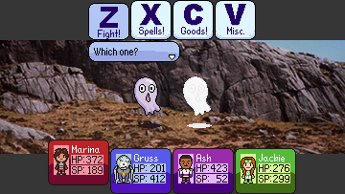

Spells! – Cast a spell or use an ability! Costs SP.

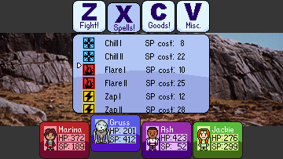

Goods! – Use an item from that characters inventory.

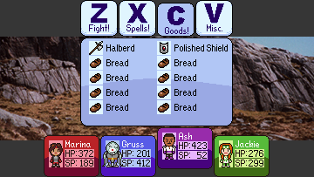

Misc. – Defend, Run Away, etc.

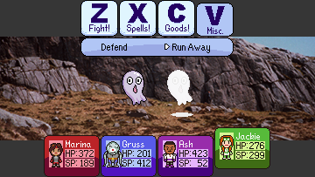

Battle begins after making contact with an enemy on the overworld.

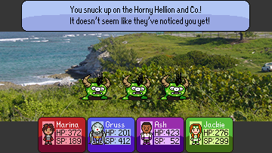

-Some flavor text is displayed. Slime draws near!

Local Missionary just wants to talk!

-Next, choose an action for each character, going

down the list (Marina first, Jackie last)

-The turn plays out, move order determined by

Speed stat.

-Repeat until all enemies are defeated or Game

Over

-After the fight, the party earns EXP and Gold for their efforts. An unconscious party member will not gain EXP.

The player is returned to the overworld.